Deploying to Heroku & using project 3 template

Things to remember before deployment:

* Using input() without a new line character will cause what the user is inputting to not appear on the terminal (e.g. use: input(“Please enter your name:\n”) instead of input(“Please enter your name:”)
* Create list of requirements (list of dependencies) using the following command: pip3 freeze > requirements.txt

Log into Heroku: <https://heroku.com/>

# Step 1:

Click New in the top right-hand (RH) corner of your dashboard and select ‘Create New App’

# Step 2:

Create a name for your app and select the region. Then click ‘Create app’ button

# Step 3:

Select the Settings tab first

*Note: Config Vars is only used if you are using a creds.json file skip to next step if you’re not using one*

The first settings to set are under the heading ‘Config Vars’. Config vars are environment variables that contain sensitive data that needs to be kept secret. Think API keys or the creds.json file

Click on Reveal Config Vars

Fill in the CREDS as the KEY value and copy and paste the json from your creds.json file as the VALUE and then click the Add button

You then have to add another KEY and VALUE pair with PORT and 8000 respectively and Add them too



# Step 4 Add Buildpacks:

Scroll further down in settings and click the ‘Add buildpack’ button under the heading Buildpacks

Project 3 uses Python so select that and Save changes

You’ll also need to add nodejs the same way to handle the mock terminal code CI provide.

You’re buildpacks should look like the below image **and be in this order**.

# Step 5:

Go to the Deploy tab

Go to the Deployment method section and select GitHub

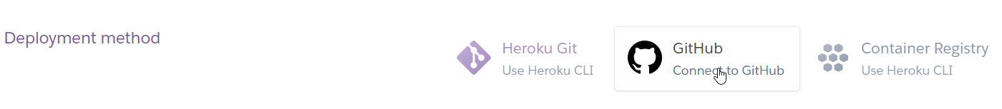

Then in the Connect to GitHub Section click the Connect to GitHub button:

Then click Authorize Heroku button (note: you may need to login in this window) make sure it’s your account before you do and pop in your password.

Search for the project and Connect it (yes I know I spelt sandwiches wrong :/ haha)

# Step 6:

You can choose to deploy in two ways:

The Automatic deploys Section will allow you to deploy your site in such a way that it will update the site every time you push new code to your repo

The Manual deploy Section will allow you to deploy your site as it is the moment you deploy and any changes made after wont be added to your site until you do a manual deploy again.